Task One: Design Documentation

dane jarvie

2521969

djar004

**Compsci 345 Assignment3**

Realizing a design

PERSONA:

Name: Karen

Age: 47

Relationship status: Married to Richard.

Children: Two, Charlotte (17), and Daniel (14).

SCENARIO:

Richard is overseas on business and Daniel is on a school trip out of town. It is Thursday evening(6.30pm) and Karen is still at work. Charlotte is due home shortly from dance class, she is being dropped home by a friend’s parent.

Karen decides to use XYZ to:

1. Turn on Path and Door lights for Charlotte. She leaves XYZ open and continues working.
2. A few minutes later she gets a text from Charlotte asking her to let her in to the house as she has forgotten her key. Karen uses XYZ to perform the following tasks:
   1. Open the large Entrance menu to observe that Charlotte is at the front door.
   2. Use the Push to Talk button to say hi to Charlotte, and let her know she is leaving soon.
   3. Turn off the alarm.
   4. Unlock the door.
   5. Turn on the foyer lights. Set the dimmer to 50%.
   6. Turn on Kitchen lights.
   7. Logout of XYZ.

WALKTHROUGH WITH WIREFRAMES

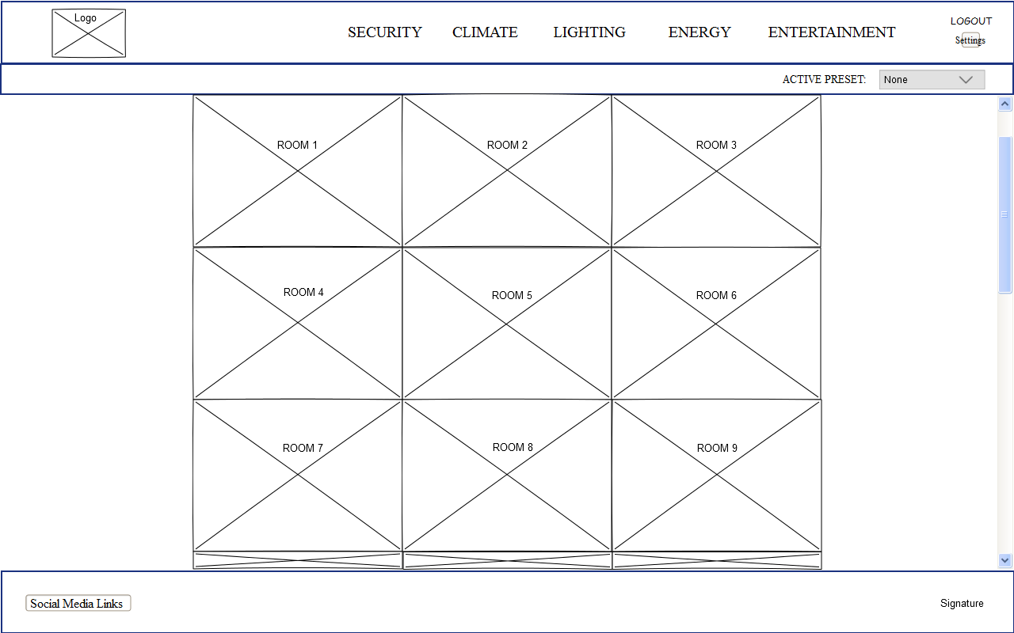

Figure 1

Figure1 represents the layout of the main screen that the user would see upon logging into their XYZ account.

The header bar houses:

1. the XYZ logo. The logo functions as a home button to return the user to this screen at any time.

Links to broad control pages for the five categories of user control. These links are not implemented for this prototype but the intention is that they would take you to a separate page that would have all the devices pertaining to that category for the entire house.

1. The logout button. Logs the user out and takes them to the login screen.
2. A settings button. Not implemented for this prototype.

The Active Pre-set bar divides the header from the Rooms Menu, see figure 2 and explanation of functionality below.

The next section is the rooms menu and is intended to be the common method for a user to adjust settings for a device. The grid of images are images that represent rooms of the home. When the user hovers the mouse over one of the room images, the image is hidden and a small menu of often used options appears in its place along with a large button with the room name and an icon suggesting the button presents more options. Only the menus for Entrance and Kitchen have been implemented in the prototype.

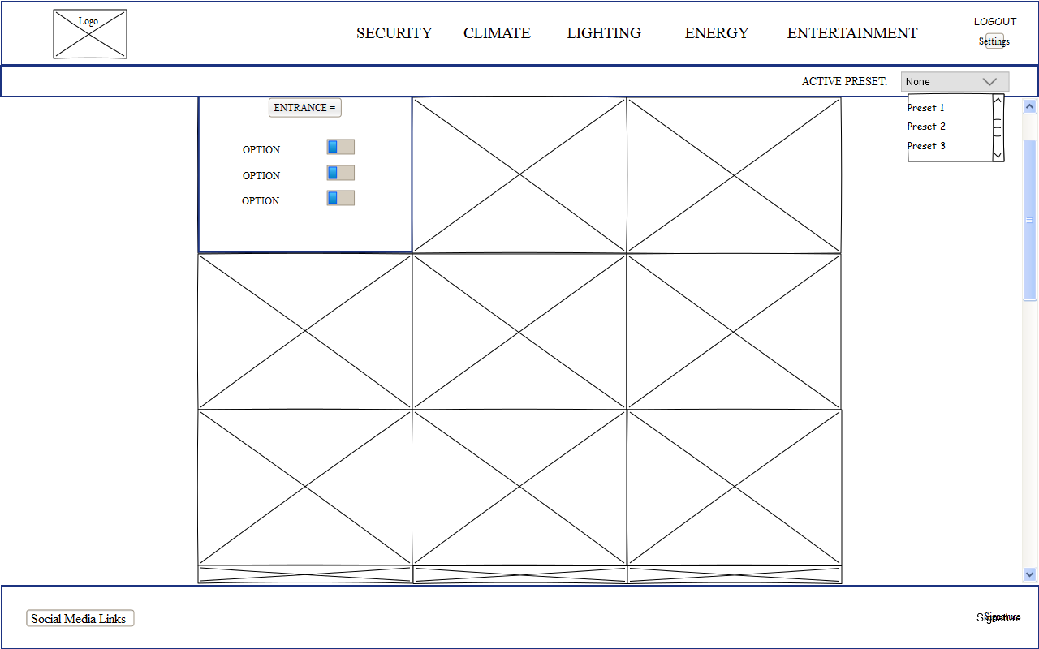

Figure 2

Figure 2 demonstrates the dropdown functionality of the Active Pre-set menu. The pre-set menu bar houses a dropdown that the user can use to quickly implement a set of settings pre-sets. The pre-sets are customisable settings that can be selected to set the status of multiple devices simultaneously. For example, a setting called “Movie Night” might turn off certain lights in the living room, dim others, set the audio output to ‘cinematic’ etc.

Figure 2 also demonstrates the functionality of the Entrance menu if the user hovers the mouse over the Entrance image frame. The Entrance menu will only be visible while the mouse is within the bounds of the frame, otherwise it is hidden and the image is visible.

If the user clicks the button within a room menu, a larger menu for that room will appear as shown in figure 3.

Figure 3 demonstrates that the larger menu for a room offers more options for that room including any available camera feeds. Our prototype has implementation for the Entrance menu. The Entrance menu has one camera feed and also has a Push to Talk button that allows communication with people at the front door.

The device buttons here are not implemented but would open a menu in a similar style as the large room menu with the full depth of options available for that device.

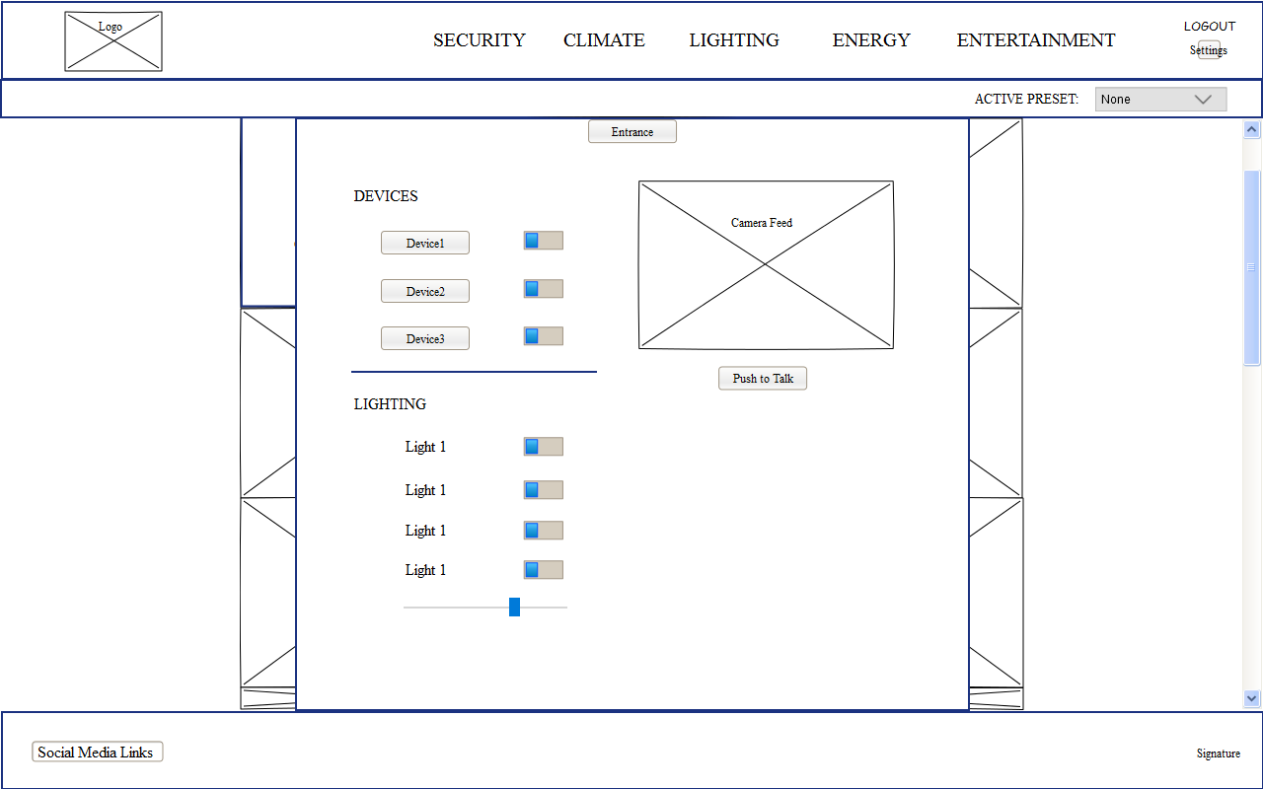

From Figure 3, the user can return to the Rooms menu by clicking the Entrance button again to hide the large menu window. (Alternatively, they could click the XYZ logo, however, this causes an unnecessary page reload).

Should the user click logout, they are taken to a login page as shown in figure 4.

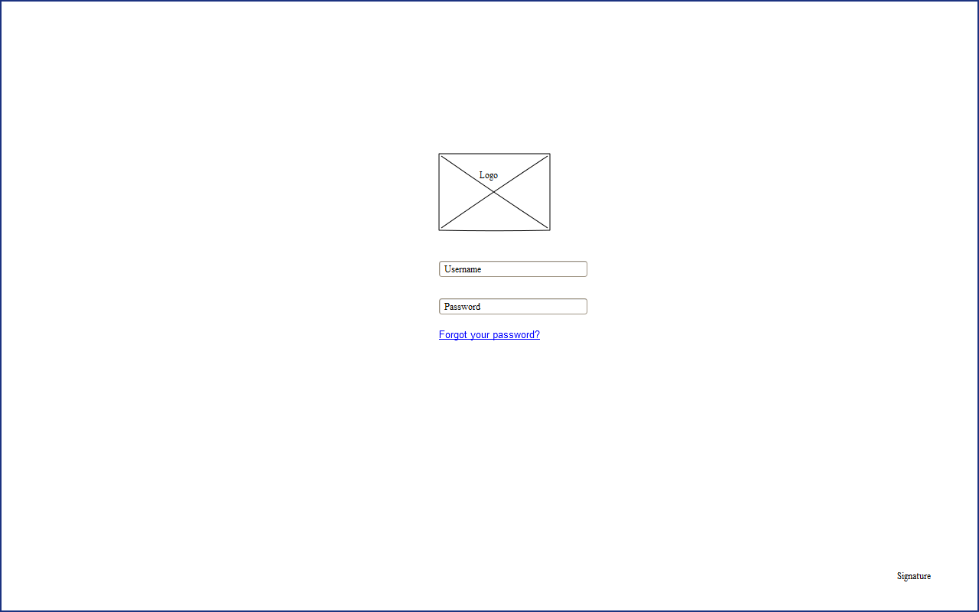

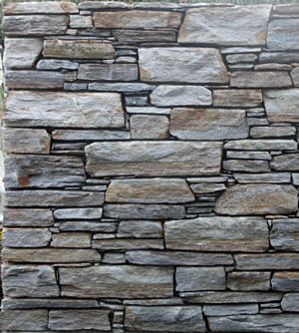Colour Scheme

The colour scheme chosen is a monochromatic scheme inspired by an image of a schist stone wall.

Schist is an expensive construction material which invokes feelings of quality, security, and warmth. The relatively neutral tones give a modern look.



RGBA(64,63,61,0.95) Used for header and footer background colour and for font and icon colouring for the menus outside the header or footer.



RGB(140,138,134) Used for the Presets bar background color.



RGB(217,213,207) Used for the Room menus and buttons background colour. Also used for the font color for text, icons and logo in the header and footer.

By using only three colours there is a simplicity to the colour scheme that is relaxing on the eye. There is satisfying contrast between the background colours and the text elements and the Pre-sets bar provides a visual transition from the darker header to the lighter room menus.

Layout Scheme

The overall look of the site is one of elegance and symmetry. It is composed almost entirely of straight vertical and horizontal lines to provide a calm atmosphere.

No white space is used in the design as it would be too contrasting against the colour scheme chosen. By keeping the elements in close proximity to one another, particularly the room images, keeps a snug feel.

The positioning of the large menu frame is centred to provide symmetry and does not fill the full width of the underlying room’s images. This is to give it a pop-out feel and a sense that you are still within one or two clicks from where you were. There is logical grouping in the menu with light switches separated from device buttons.

Resource List

The following is a list of references for the images used for the Rooms menu.

**Entrance**

<http://wakecares.com/amazing-front-door-colors-creating-shocking-splash-for-the-house/tiny-window-beside-nice-model-and-brown-front-door-colors-plus-modular-wall-design/>

**Kitchen**

<http://www.ikea.com/ms/media/cho_room/20153/kitchen/20153_cosk05a/20153_cosk05a_01_PH123798.jpg>

**Living**

<http://cdn.home-designing.com/wp-content/uploads/2013/01/modern-living-room-off-white.jpg>

**Dining**

<http://cdn.home-designing.com/wp-content/uploads/2013/01/elegant-contemporary-dining-room.jpg>

**Bathroom**

<http://cdn.freshome.com/wp-content/uploads/2014/02/Stylish-Modern-Bathroom-Design-9.jpg>

**Master** **Bedroom**

<http://st.hzcdn.com/simgs/2ed1f69300d3e6c8_4-4301/contemporary-bedroom.jpg>

**Bedroom 2**

<http://hgtvhome.sndimg.com/content/dam/images/hgtv/fullset/2014/10/13/0/Amy-Elbaum_DC-Condo-master-bedroom.jpg.rend.hgtvcom.1280.960.jpeg>

**Laundry**

<http://cdn.decoist.com/wp-content/uploads/2014/01/Modern-clean-lined-laundry-room.jpg>

**Master Ensuite**

<https://gauciandcodotcom1.files.wordpress.com/2013/03/ls_wv_grosvenorsh_47058_col.jpg>

**Outdoor**

<http://outdoor.dragonhousebook.com/wp-content/uploads/2015/11/Modern-Outdoor-Kitchen-Sets.jpg>

**Garage**

<http://www.amarr.com/images/homepage-slideshow/home5.jpg>

**Bedroom 3 (Teen Room)**

<http://www.minimalisti.com/wp-content/uploads/2015/06/modern-boy-bedroom-furniture-wall-shelf-desk-lighting-ideas.jpg>

Resource List continued.

**charlotte-home.jpg**

A photo taken by me. Used to represent the camera feed for the security camera for the Entrance.

**logo.png**

Custom created by Hayley Emery of Yellow Door Design. www.yellowdoor.co.nz

**Schist Wall**

http://www.celticstonework.co.nz/types-of-stone/hyde-grey.aspx

Used as inspiration for the colour scheme.

**Bootstrap Javascipt Library**

<http://getbootstrap.com/>

The bootstrap library that provides CSS and Javascript for html elements. Used glyphicons and dependency support for the Toggle and Slider add ons.

**Bootstrap Toggle**

<http://www.bootstraptoggle.com/>

A Javascript/CSS library that provided ability to implement the toggle switches.

**Bootstrap Slider**

<https://github.com/seiyria/bootstrap-slider>

A Javascript/CSS library that provided ability to implement the range slider that represent light dimmers.

**Font Awesome**

<http://fontawesome.io/>

Provided the social media icons.

**Maven Pro Font**

Google Fonts. Provided the font for the website and report.